

SRM INSTITUTE OF SCIENCE AND TECHNOLOGY
RAMAPURAM CAMPUS
FACULTY OF ENGINEERING AND TECHNOLOGY
DEPARTMENT OF ELECTRONICS & COMMUNICATION ENGINEERING
CONTINUOUS LEARNING ASSESMENT–II
Sub Code/Name : 18ECO107T FIBEROPTICS & OPTOELECTRONICS Set : A
Class/Sem/Course :IIIYr / VISem / B. Tech -CSE (ALL DISCIPLINE) & IT Date : 2023
Max Marks :50 Duration: 90 mins
PART-A ( 10 x 1 = 10)
ANSWER ALL THE QUESTIONS
Q.No. | Question | Marks | CO | BL | PI
1 | For no overlapping of light pulses down on an optical fiber link, the digital bit rate BT must be ___________  a) Less than the reciprocal of broadened pulse duration  b) More than the reciprocal of broadened pulse duration  c) Same as that of than the reciprocal of broadened pulse duration  d) Negligible | 1 | 2 | 2 | 1.3.1
2 | 3dB optical bandwidth is always ___________ the 3dB electrical bandwidth  a) Smaller than  b) Larger than  c) Negligible than  d) Equal to | 1 | 2 | 1 | 1.3.1
3 | Give the expression for group velocity(ω-angular frequency, β-propagation constant)  a .υ_{g}=dω/dβ  b. υ_{g}=dβ/dω  c. υ_{g} =dω*dβ  d. υ_{g} =dω+dβ | 1 | 2 | 2 | 1.3.1
4 | Identify the wavelength of the optical spectrum which produces maximum attenuation  a) 850nm  b) 900nm  c)1300nm  d)1400nm | 1 | 2 | 1 | 1.3.1
5 | Write the equations for finding attenuation in optical fiber  a) α_{ρ} = zln[p(0)/p(z)]  b) α_{ρ} =1/z[p(0)/p(z)]  c) α_{ρ} =1/zln[p(0)/p(z)]  d) α_{ρ} =1/zln[p(z)/p(0)] | 1 | 2 | 1 | 1.3.1
6 | ____________ confinement is used to increase the carrier concentration recombination at the active region  a) Carrier  b) Optical  c)Electrical  d)Signal | 1 | 3 | 1 | 1.3.1
7 | An incandescent lamp is operating at a temperature of 1000K at an operating frequency of 5.2×10¹⁴ Hz. Calculate the ratio of stimulated emission rate to spontaneous emission rate.  a) 3×10⁻¹³  b) 1.47×10⁻¹¹  c) 2×10⁻¹²  d) 1.5×10⁻¹³ | 1 | 3 | 3 | 2.1.3
8 | An LED has lower output power,____ switching speed and ___________ spectral width than the LASER as an optical source.  a) slower, higher  b) faster, higher  c) faster, lower  d) slower, lower | 1 | 3 | 1 | 1.3.1
9 | Identify the device which is NOT a common light detector  a) PIN photodiode  b) Photovoltaic diode  c) Photodiode  d) Avalanche photodiode | 1 | 3 | 1 | 1.3.1
10 | A photo diode is incident with optical power of 1 W, if the detected across its terminals is 100 mA then Responsivity of the photo diode is  a) 0.1  b)0.5  c)1  d)100 | 1 | 3 | 3 | 2.1.3

PART-B ( 4 x 4 = 16)
ANSWER ANY FOUR QUESTIONS
Q.No. | Question | Marks | CO | BL | PI
11. | Compare intramodel and intermodal dispersion | 4 | 2 | 1 | 1.2.1
12. | Explain about intrinsic absorption in optical fiber | 4 | 2 | 2 | 1.2.1
13. | Discuss about dispersion in optical fiber | 4 | 2 | 1 | 1.2.1
14. | Differentiate between luminescence and incandescence | 4 | 3 | 2 | 1.2.1
15. | Comment on quantum efficiency. | 4 | 3 | 1 | 1.2.1
16. | List out the types and advantages of photodiode. | 4 | 3 | 1 | 2.1.2

PART - C ( 2 x 12 = 24)
ANSWER ALL THE QUESTIONS
Q.No. | Question | Marks | CO | BL | PI
17a. | A 6km optical link consists of multimode step index fiber with a core refractive index of 1.5 and a relative refractive index of 1%. Estimate the delay difference between the slowest and fastest modes at the fiber output and the rms pulse broadening due to intermodal dispersion on the link. Also derive the expression involved in it.  (OR)  Discuss the attenuation encountered in optical fiber communication  due to Bending, Scattering and Absorption. | 12 | 2 | 3 | 2.1.3
17b. |  | 12 | 2 | 2 | 2.1.3
18a. | Discuss and Compare surface emitting and edge emitting LED structures.  (OR)  With a neat sketch explain the principle and operation of PIN and Avalanche photodiode. | 12 | 3 | 3 | 2.1.3
18b. |  | 12 | 3 | 2 | 2.1.2

Outcome Alignment Matrix:
QUESTION  NUMBER | CO distribution
QUESTION  NUMBER | CO1 | CO2 | CO3 | CO4 | CO5
1 |  | 1
2 |  | 1
3 |  | 1
4 |  | 1
5 |  | 1
6 |  |  | 1
7 |  |  | 1
8 |  |  | 1
9 |  |  | 1
10 |  |  | 1
11 |  | 1
12 |  | 1
13 |  | 1
14 |  |  | 1
15 |  |  | 1
16 |  |  | 1
17a |  | 1
17b |  | 1
18a |  |  | 1
18b |  |  | 1
Total |  | 41 | 41
% |  | 50% | 50%

Quality Matrix:
Question No. | BL Distribution
Question No. | L1 | L2 | L3
1 |  | 1
2 | 1
3 |  | 1
4 | 1
5 | 1
6 | 1
7 |  |  | 1
8 | 1
9 | 1
10 |  |  | 1
11 | 4
12 |  | 4
13 | 4
14 |  | 4
15 | 4
16 | 4
17a |  |  | 12
17b |  | 12
18a |  |  | 12
18b |  | 12
Total | 22 | 34 | 26
% | 27% | 41% | 32%

Bloom’s level Distribution:

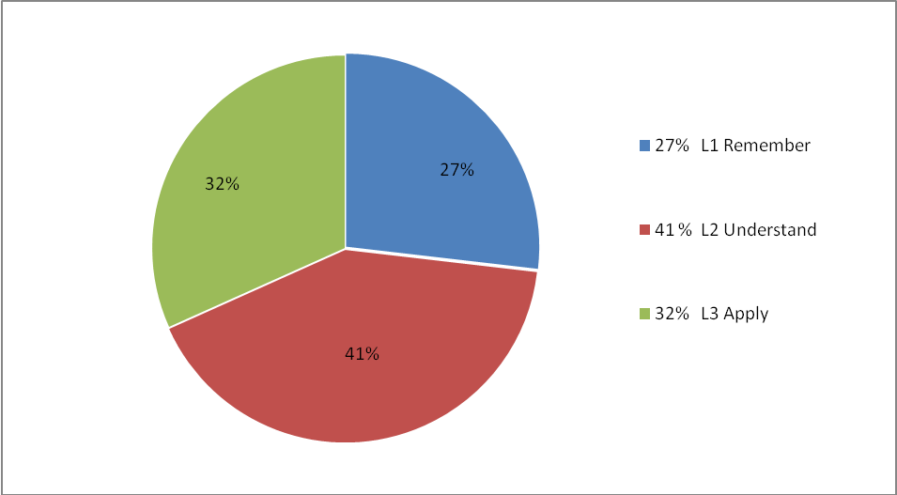

Prepared by: Scrutinised by:
Dr.P.Ramani V.Reji

Verified and approved by HOD

